**Welspun Global Service**

Survey No. 76, Village Morai, Vapi, District Valsad, Gujarat 396191, India.

**Entity: WEL**

**WORK FLOW DOCUMENT**

**A.1 Disclaimer:**

This document has been prepared based on information/data provided by WEL. The document may be optimized or changed based on more information provided by WEL. Welspun Global Services does not assume any responsibility for inaccuracies, errors, or omissions that may be contained herein. In no event will Welspun Global Service be held liable for direct, indirect, special, incidental, or consequential damages resulting from any defect or omission in this document or/and the solution, even if advised of the possibility of such damages.

Welspun Global Service is space of Consulting and Solution Provider and does not have any control on product, Technology or Solution offered by Automation Anywhere and hence will not be liable for any defect, issues, loss of business, damages faced by customer for problems related to Product, Technology and Support offered by Automation Anywhere. We have shared overall requirement and current setup details with Automation Anywhere and the proposed solution is in line with their recommendation.

The solution referred to in this document has been designed as per Welspun Global Service understanding of the Customer's overall solution requirements. The performance of individual components therein may differ when functioning as part of the overall solution as compared to what the individual component is capable of delivering. Welspun Global Service hereby disclaims warranty on the performance of the individual components in the above circumstances.

A.2 Process Name: Procurement flow tool

# A.3 Process scope

# This process is done for WEL entity

# A.4 Process Description

|  |  |  |
| --- | --- | --- |
| Sr. No. | Particulars | Details |
| 1 | Process Name | Procurement flow tool |
| 2 | Development Initialization date |  |
| 3 | Complexity | Medium |
| 4 | SSC Head | Mr Nitin Jain |
| 5 | Project Manager | Mr Saurabh Verma |
| 6 | Project Lead | Ms Bhagyashri Wayare |
| 7 | Process Owner | Mr Kedar Nath Bansal |
| 8 | Activity Owner | Mr Anil Gahlyan |
| 9 | Developer Lead |  |

A.5 Document History

|  |  |  |  |  |  |
| --- | --- | --- | --- | --- | --- |
| Version | Created/ Updated by | Creation/ Updation date | Changes done | Signed off by | Signed off date |
| Base Version | Anup Gupta | 19 January 2023 | Base version |  |  |

A.6 Current Environment

* RFQ’s are receiving thru email.
* RFQ’s are initiated by SCM team thru email.
* All offers and other technical data are shared thru email to Technology Partner (Xylem) & Eau Labs (WEL – Consultant).
* Comments / observation on offers have been shared thru email by Xylem & Eau Labs.
* All communication for technical clearance / approval from Xylem, Eau Labs, and WEL team are communicated through mail.
* PO / Manufacturing clearance to be released after receipt of approvals from concern authorities.

A.7 Applications used in current process

|  |  |  |
| --- | --- | --- |
| Sr. No | Current sources | Applications/ files/ folders |
| 1 | Outlook | All the approvals/ review & status update of RFQ are sent through mail. |

A.8 Process As is

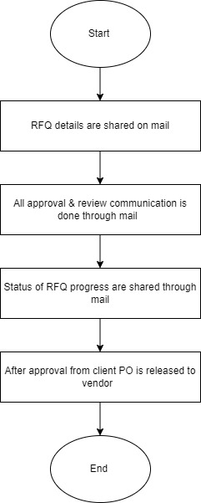

**PO will be issued after receipt of technical clearance and approval from concern authorities as per GAM.**

**Manufacturing clearance will be issued after receipt of client approval (For activity 1 as per flow chart)**

A.9 Process use cases

* Xylem member will initiate the tool through link.
* Fill the details of RFQ in tool & submit.
* Details will be sent & action will be taken accordingly at each level.
* Update of RFQ will be sent through auto mail.

A.10 Process To Be

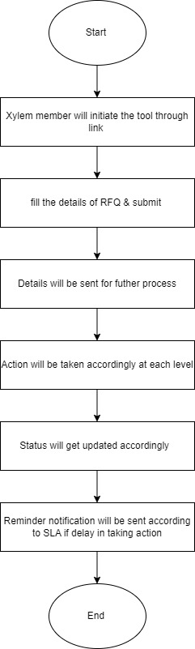

A.11 Applications used in process

|  |  |
| --- | --- |
| Sr. No | Applications |
| 1 | Power App |
| 2 | Power automate |
| 3 | Share point |

A.12 Tool Description

|  |  |
| --- | --- |
| Sr. No | Tool description |
| 1 | * Fields in tool   Below are the field name for which details have to be filled by initiator   * RFQ no: this will be filled by initiator * Description: this will be filled by initiator * Date: this will be auto generated. Here RFQ details submission date will appear. * Remark: this will be filled by initiator * Submit   Once details are submitted by initiator it will be sent to next level **and auto update will be received over the email.** |
| 2 | * When details will be sent to next level then he will be able to edit description, remark. RFQ no & date will become uneditable. * **In case there is any revision in RFQ due to comments marked by next level, the revision date must reflect on revision of document.** * At each level remark/ comment option will be provided & actioner will enter his remark/ comment. |
| 3 | Reject/ Approve /Comment: if there will be any change or error at any level then actioner will be able to comment / reject. The details & notification will be sent to previous actioner and he will update accordingly & submit details for further process. |
| 3 | Auto notification will be sent to previous actioner & next actioner according to update in process. |
| 4 | Auto notification will be sent to actioner if any action is not taken according to SLA time line. Only working day will be considered for calculating time of activities. |
| 5 | Customized reminder tab will be provided in tool through which customized reminder can be sent. |
| 6 | There will be two activities for RFQ in tool. In progress and complete.  The status will reflect as complete only and after issuing of **Manufacturing clearance** for particular RFQ.  The status will reflect as complete only and after delivery and completion of MIGO in SAP.  Until then the status will be reflect as “in progress”. |
| 7 | Power BI dashboard  Dashboard will show details of RFQ with status, ageing & department wise RFQ status. Report can be downloaded from dashboard in excel format. |

A.13 Activity with responsibility & duration to complete it.

|  |  |  |  |
| --- | --- | --- | --- |
| Sr. No | Activity Name | Responsibility | Duration of activity (days) |
| 1 | RFQ by Xylem | Xylem | Initiator |
| 2 | RFQ Review by Eaulabs | Eau | 2 |
| 3 | Revised RFQ by Xylem | Xylem | 2 |
| 4 | Approval of RFQ by Eaulabs | Eau | 1 |
| 5 | Release of RFQ to Vendors | SCM | 0 |
| 6 | Proposal submission by vendors | SCM | 21 |
| 7 | Technical Offers to Xylem & Eaulabs for review | SCM | 0 |
| 8 | Review of QAP | Quality (WEL) | 1 |
| 9 | TQR by Xylem & Eaulabs | Xylem & Eau | 7 |
| 10 | TQR to vendors | SCM | 0 |
| 11 | Response to TQR by bidders | SCM | 7 |
| 12 | Technical discussion with vendors (If required) | Engg/Xylem/Eau | 7 |
| 13 | Technical comparison table  (Including recommendation) | Xylem/Eau | 4 |
| 14 | Price comparison, negotiation & selection of final vendor. | SCM | 7 |
| 15 | Compiled technical documents by Eau & Xylem for final selected vendor | Eau/Xylem | 2 |
| 16 | Release of Purchase Order | SCM | 5 |
| 17 | Technical documents submission by vendor | SCM | 21 |
| 18 | Review of documents for client submission | Engg/Xylem/Eau | 4 |
| 19 | Sending comments to vendor | SCM | 0 |
| 20 | Submission of revised documents by vendor | SCM | 7 |
| 21 | Review of revised documents for client submission | Engg/Xylem/Eau | 2 |
| 22 | Submission of documents to TCE/BMC for approval | Project Owner WEL | 1 |
| 23 | Receipt of comments from TCE/BMC | Project Owner WEL | 15 |
| 24 | Sending comments to vendor for revised submission | SCM | 1 |
| 25 | Submission of revised documents by vendor on TCE/BMC comments | SCM | 5 |
| 26 | Review of revised documents for client submission | Engg/Xylem/Eau | 2 |
| 27 | Submission of revised documents to TCE/BMC for approval | Project Owner | 2 |
| 28 | Receipt of approval from TCE/BMC | Project Owner | 14 |
| 29 | Issue of manufacturing clearance to vendor | Engg/SCM | 0 |
| 30 | Receipt of manufacturing plan from vendor | SCM | 14 |
| 31 | Manufacturing period as per PO terms | SCM |  |
| 32 | Stage inspection as per approved QAP (if any) | Engg/SCM |  |
| 33 | Receipt of inspection call from vendor | SCM | 2 |
| 34 | Final inspection / Preparation of Inspection report | Engg/Project Owner | 1 |
| 35 | Submission of final reports to TCE/BMC for dispatch clearance | Project Owner | 1 |
| 36 | Receipt of dispatch clearance from TCE/BMC | Project Owner | 2 |
| 37 | Issue dispatch clearance to vendor | SCM | 0 |
| 38 | Packing of material after dispatch clearance | SCM | 5 |
| 39 | Dispatch from vendor works | SCM | 3 |
| 40 | Material delivery at site | SCM | 15 |
| 41 | Inspection of material at site as per PO and approved documents | Store Team | 5 |
| 42 | MIGO in SAP | Store Team | 2 |